CERTIFICATION OF COMPLIANCE & FWA TRAINING AND COMPLIANCE PROGRAM & STANDARDS OF CONDUCT COMPLETION
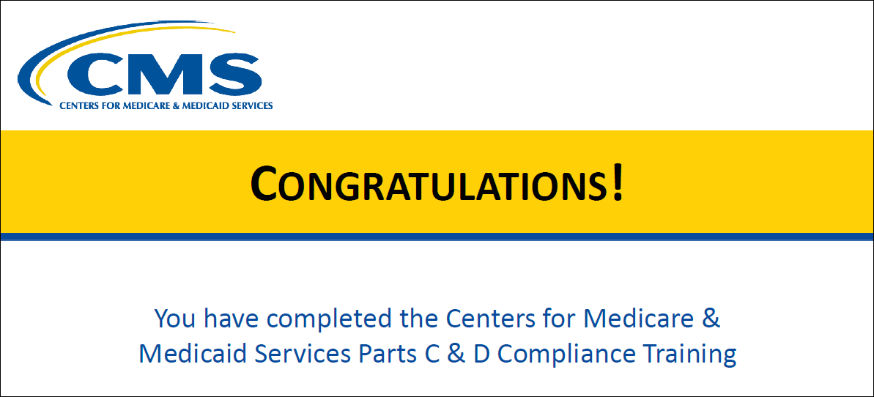

I hereby certify that I have completed CMS’ Compliance and FWA Training and read PacificSource’s Compliance Program and Standards of Conduct.
<TYPE YOUR NAME HERE>
<Insert Today’s Date>

This record must be trained be documented and retained for a period of 10 years. Proof of training attendance and completion will be subject to PacificSource and CMS audit and verification.

